Quiz 1

Question 3.

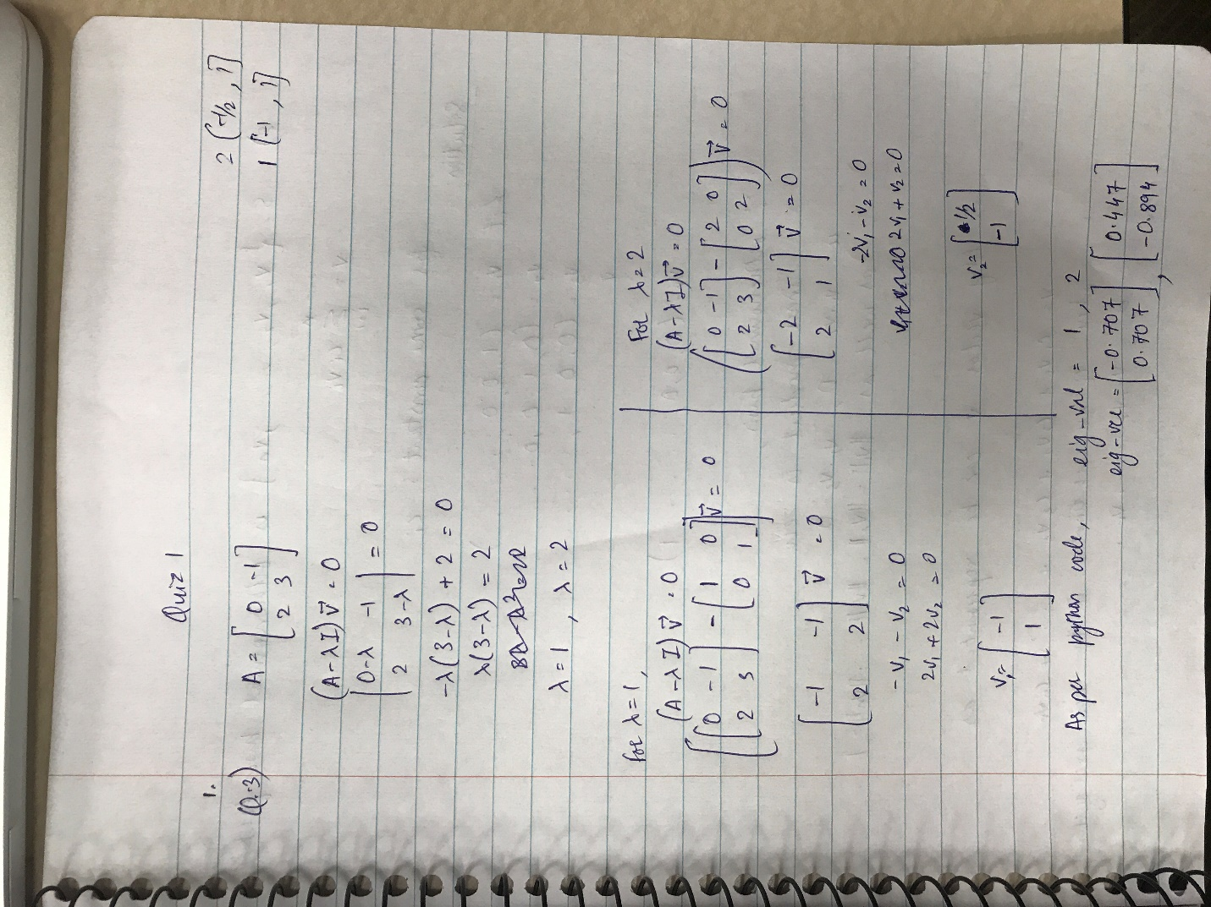

The eigen values are same in both solutions and the eigen vector have the same ratio.

Question 2.

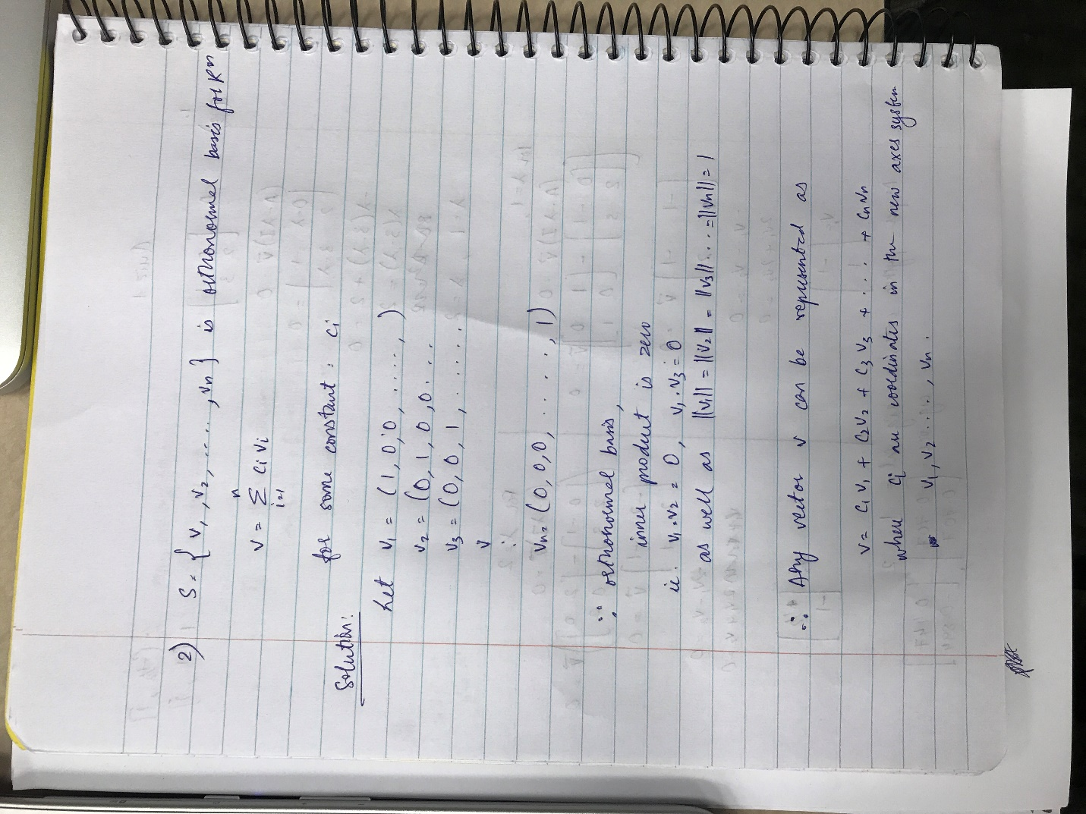

To get the value of Ci in terms of S is to calculate dot product of the vector with Vi

Ci is the projection of vector v along vi axes respectively.

